OVERVIEW
Chelmsford is a suburban community of 35,067 residents located just southwest of Lowell in Middlesex County. Originally founded as a farming town, Chelmsford retains much of its original character. The majority of the housing in Chelmsford consists of single-family homes, however there are also apartment complexes and multi-family homes.

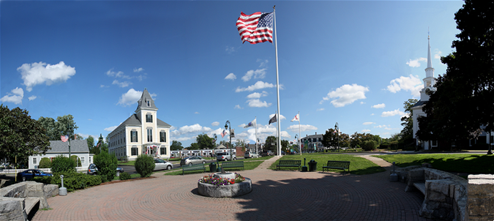
Chelmsford Town Common (Photo Source Town of Chelmsford)

Community safety
In 2016, the Town of Chelmsford’s violent crime rate was 79% lower than the national average and 78% lower than the Massachusetts average. The property crime rate was 51% lower than the national average and 23% lower than the Massachusetts average.

Data Source: www.cityrating.com/crime-statistics

Transportation
Most residents of Chelmsford rely on a car for transportation; both Route 3 and I-495 run through town. Public Transportation in town is limited; however, the LRTA 14, 16, 17, 4, and 15 buses serve Chelmsford. The nearest Commuter Rail Station is either in Lowell or Billerica depending on what part of Chelmsford you are in.

Schools

Byam Elementary School (K – 4)
Great Schools Rating: 6/10

Center Elementary School (K – 4)
Great Schools Rating: 7/10

Harrington Elementary School (K – 4)
Great Schools Rating: 6/10

South Row Elementary School (K – 4)
Great Schools Rating: 7/10

McCarthy Middle School (5 – 8)
Great Schools Rating: 6/10

Parker Middle School (5 – 8)
Great Schools Rating: 8/10

Chelmsford High School (9 – 12)
Great Schools Rating: 9/10

Nashoba Valley Technical High School (9 – 12)
Great Schools Rating: 5/10

High School Graduation Rate
Chelmsford High School | 97.2%
Massachusetts | 87.9%

Data Sources: GreatSchools.org; MA Dept. of Elementary & Secondary Education District Profiles

DEMOGRAPHICS
Poverty Rate: 3.6%

Race/Ethnicity | %
White | 88.4%
Asian | 10.2%
American Indian and Alaska Native | 0.5%
Hispanic or Latino | 3.7%
Black/African American | 1.1%
Native Hawaiian and Other Pacific Islander | 0.1%
Other | 1.1%

Age Group | %
Under 5 | 5.6%
Age 5-17 | 14.8%
Age 18-64 | 61.6%
Age 65 and older | 18.0%

Data Source: American FactFinder, U.S. Census Bureau

Local Amenities

Within the Town of Chelmsford, there are many shopping plazas and restaurants, including multiple supermarkets. In addition to these shopping centers the Pheasant Lane Mall in Nashua, NH is a short drive away, as is the Burlington Mall.

Chelmsford hosts many community events including Winterfest, a July 4th Parade & Country Fair, Fall Fest, and a Holiday Tree Lighting Ceremony. Chelmsford has an active community center as well as a Chelmsford Center for the Arts, which host additional community events.

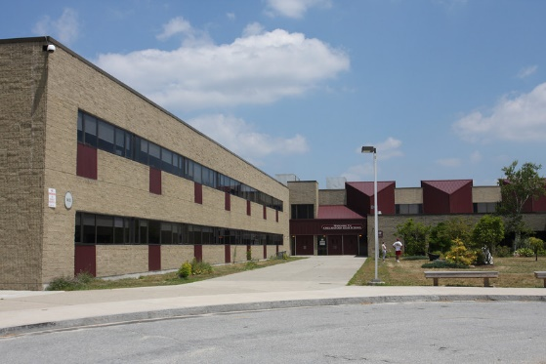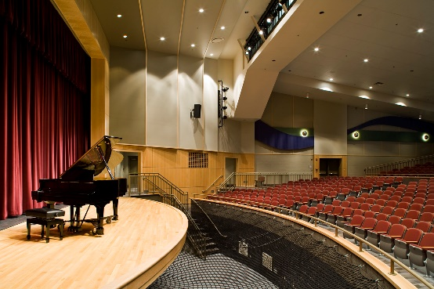
Chelmsford High School (Photo Source: Chelmsford Patch/Flansburgh Architects)

MAP

