OVERVIEW
Tyngsborough is a rural community of 12,232 residents located just west of Lowell, and just south of Nashua, NH. The town is located along the Merrimack River and was originally known for its ferries and quarries. The housing in town is primarily single-family homes; however, they also have a number of apartment complexes and multi-family homes.

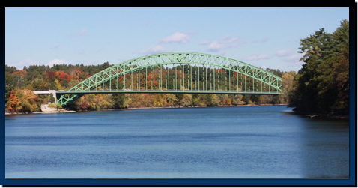
Tyngsborough Bridge (Photo Source Tyngsborough Water District)

Community safety
In 2016, the Town of Tyngsborough’s violent crime rate was 76% lower than the national average and 74% lower than the Massachusetts average. The property crime rate was 79% lower than the national average and 67% lower than the Massachusetts average.

Data Source: www.cityrating.com/crime-statistics

Transportation
Most residents of Tyngsboro rely on a car for transportation; Route 3 runs through town. Public Transportation in town is limited, however there is service provided by the LRTA 10 bus. Additionally, Tyngsboro Park & Ride provides bus service into Boston, and the nearest Commuter Rail Station is located in Lowell.

Schools

Tyngsborough Elementary School (Pre-K – 5)
Great Schools Rating: 5/10

Tyngsborough Middle School (6 – 8)
Great Schools Rating: 5/10

Tyngsborough High School (9 – 12)
Great Schools Rating: 7/10

Greater Lowell Technical High School (Grades 9 – 12)
Great Schools Rating: 4/10

High School Graduation Rate
Tyngsborough High School | 98.2%
Massachusetts | 87.9%

Data Sources: GreatSchools.org; MA Dept. of Elementary & Secondary Education District Profiles

DEMOGRAPHICS
Poverty Rate: 7.1%

Race/Ethnicity | %
White | 91.1%
Asian | 10.8%
American Indian and Alaska Native | 0.4%
Hispanic or Latino | 3.1%
Black/African American | 1.0%
Native Hawaiian and Other Pacific Islander | 0.0%
Other | 0.2%

Age Group | %
Under 5 | 4.1%
Age 5-17 | 16.9%
Age 18-64 | 69.2%
Age 65 and older | 9.8%

Data Source: American FactFinder, U.S. Census Bureau

Local Amenities

Tyngsborough has a thriving business community and has many restaurants and stores either in town or only a short drive away in Nashua, NH. Half of the Pheasant Lane Mall is located in Tyngsborough, with the other half in Nashua, NH, this makes for easy access to shopping.

The town of Tyngsborough has hundreds of acres of protected forests, meadows, and wetlands with trails open to the public year round including the Tyngsborough/Lowell/Dracut State Forest. The town also provides easy access to the Merrimack River, and has its own public beach at Lake Mascuppic.

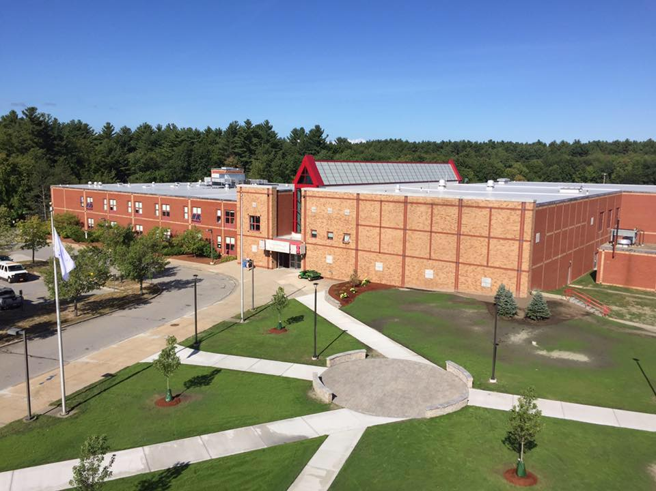
Tyngsborough High School (Photo Source: Tyngsboro Public Schools)

MAP

