OVERVIEW
Westford is a suburban community of 24,087 residents located just south of the New Hampshire border, and west of Lowell in Middlesex County. The town originally consisted of farms, and mills and retains much of that original character. The majority of the housing in Westford consist of single-family homes, although they do have multi-family homes and apartment complexes. Westford is a part of its own Westford Public Schools District.

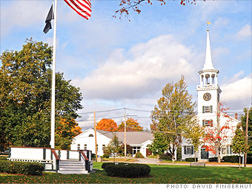
Westford Town Common (Photo Source CNN.com)

Community safety
In 2016, the Town of Westford’s violent crime rate was 78% lower than the national average and 77% lower than the Massachusetts average. The property crime rate was 85% lower than the national average and 77% lower than the Massachusetts average.

Data Source: www.cityrating.com/crime-statistics

Transportation
Most residents of Westford rely on a car for transportation; both Route 3 and I-495 run through town. Public Transportation in town is limited; however, the LRTA 15 bus serves the town. The nearest Commuter Rail Stations are in Lowell and Littleton.

Schools

Robinson-Crisafulli Elementary Schools (K – 5)
Great Schools Rating: 8/10

Nabnasset-Abbot Elementary Schools (K – 5)
Great Schools Rating: 8/10

Miller-Day Elementary Schools (K – 5)
Great Schools Rating: 6/10

Blanchard Middle School (6 – 8)
Great Schools Rating: 8/10

Stony-Brook Middle School (6 – 8)
Great Schools Rating: 8/10

Westford Academy (9 – 12)
Great Schools Rating: 8/10

Nashoba Valley Technical High School (9 – 12)
Great Schools Rating: 5/10

High School Graduation Rate
Westford Academy | 99.0%
Massachusetts | 87.9%

Data Sources: GreatSchools.org; MA Dept. of Elementary & Secondary Education District Profiles

DEMOGRAPHICS
Poverty Rate: 2.3%
Race/Ethnicity | %
White | 81.7%
Asian | 18.8%
American Indian and Alaska Native | 0.3%
Hispanic or Latino | 1.1%
Black/African American | 0.5%
Native Hawaiian and Other Pacific Islander | 0.1%
Other | 0.1%

Age Group | %
Under 5 | 5.1%
Age 5-17 | 22.5%
Age 18-64 | 60.1%
Age 65 and older | 12.3%
Data Source: American FactFinder, U.S. Census Bureau

Local Amenities

Within the Town of Westford there a number of shopping plazas and restaurants, including two supermarkets. Additionally, the Pheasant Lane Mall in Nashua, NH is a short drive away.

Westford hosts many annual town events, such as the Apple Blossom Festival and a Strawberry Festival in June. The town also has a small skiing and tubing area, Nashoba Valley Ski Area, a state of the art library, and a very active community center that has offerings for people of all ages.

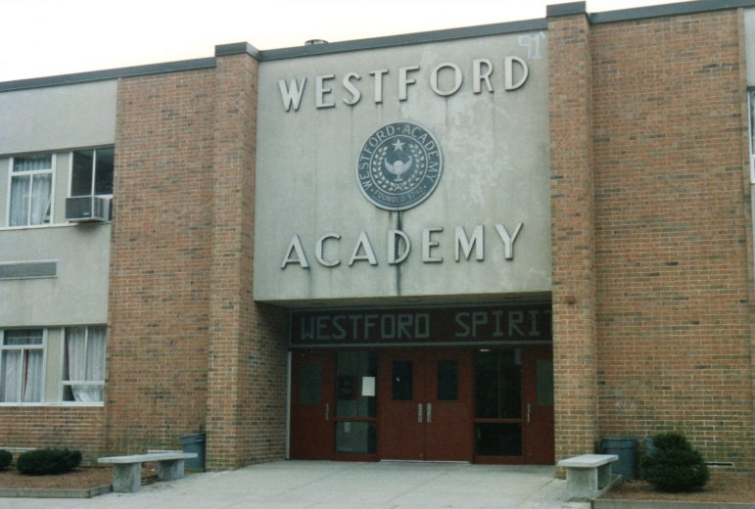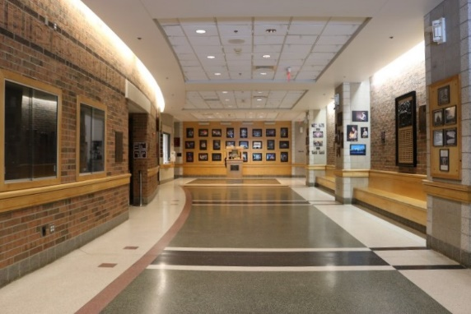
Westford Academy (Photo Source: WestfordCAT News/Westford MA Ghostwriter)

MAP

